1. <https://www.conduktor.io/kafka/producer-default-partitioner-and-sticky-partitioner/>
2. A white background with blue text

   Description automatically generated
3. A screenshot of a computer

   Description automatically generated
4. 
5. Let’s create producer properties which are configurations for our producer.
6. 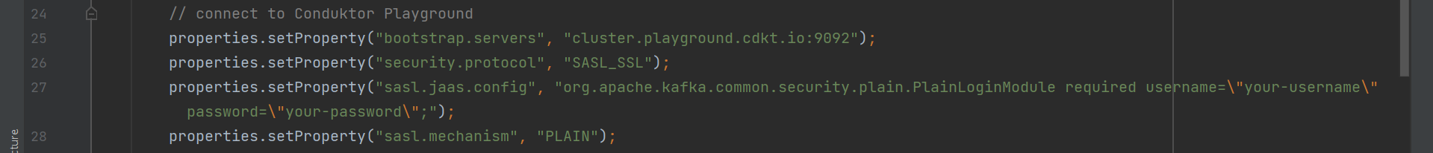
7.   
     
     
     
   